**SecuRemote® Smart**

**Quick Start Guide**

**Smart Plug**

Version 01.01.02 [Internal Draft]

Table of Contents

1 Downloading and Installing SecuRemote® Smart Application from Server 3

2 Installing SR Device 4

3 Pairing with Smart Plug as First user-Admin 5

4 Operate Smart Plug 6

5 Add New User Access Device 7

6 Invited User Device redeem “Invite Code” and pair with SR Device 8

7 Register and Configure SR Bridge to UDI Portal 9

# Downloading and Installing SecuRemote® Smart Application from Server

The application will run on all BLE 4.0 supported Mobile device. Currently work with iOS.

Download & Install SR Smart application from Apple App Store.

* + - * Go to App Store in mobile device
      * Search for “SecuRemote” or “SecuRemote Smart” application
      * Install “SecuRemote® Smart” Application
      * Or you can directly open below link on your iPhone
      * Go to below link and download app

<http://integration.belwith.com/AppStaging/InstallApps.html> and click on [Install SR Smart Application (Version 01.02.05)](itms-services://?action=download-manifest&url=https:/integration.belwith.com/AppStaging/iOS/SRSmart010202.plist)

**Application icon or logo:**



# Installing SR Device

Connect SR Smart Plug with the wire of wall box, Green Line into Earth Line. Refer below image for more detail.

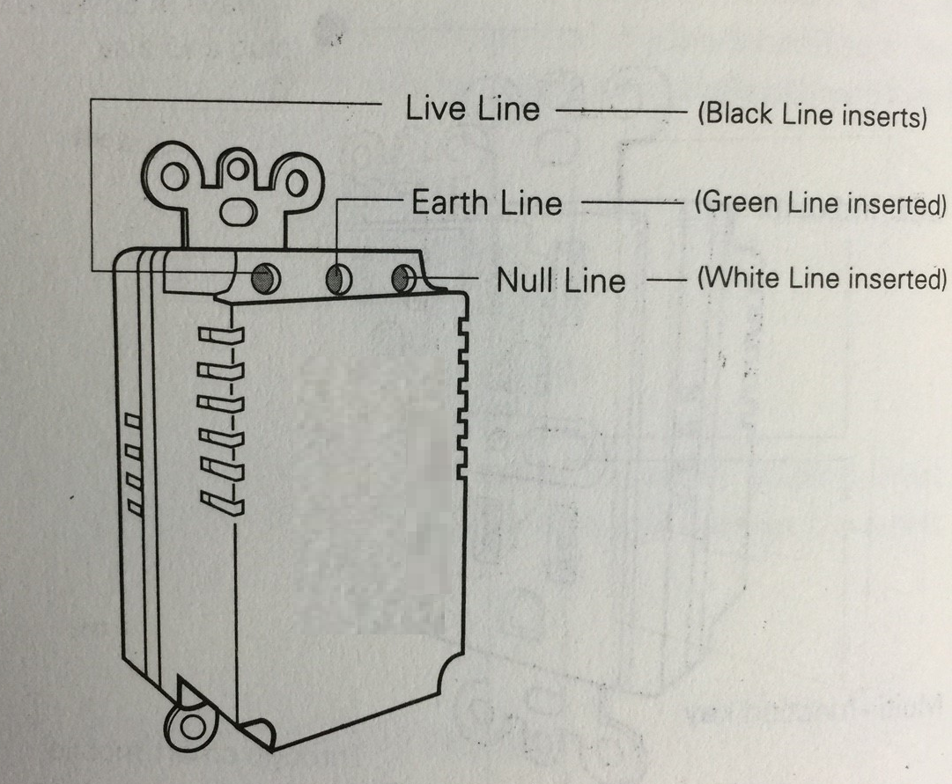

Note: Please make sure that the power has been turned off before installation.

# Pairing with Smart Plug as First user-Admin

Click on SR smart app icon. SR smart app will be launched and “Add SR Device” screen will appear.

1. User can either select “SCAN QR CODE” option or “Enter SR # manually” option.

* To add SR Device using “SCAN QR CODE”

#### Click on “SCAN QR CODE” button

#### Smart Plug info will be read successfully from label on Smart Plug, using QR scan.

##### Screen will appear with auto-filled Smart Plug information.

##### User must enter a desired name for the Smart Plug and click on “Create New Account” Button

* To add SR Device using “SR # manually” option:

#### Click on “Enter SR # manually” from “Add SR Device” screen.

#### Enter SR # and Security Token from label attached to SR Device manually in “Add SR Device” screen.

* + User must enter a desired name for the Smart Plug and click on “Create New Account” Button

#### Click on “Create New Account” button. “Create SR Account” screen will appear. User must provide email address and password to create a new account on SRP.

#### Power on SR Smart plug and enter all necessary account information in mobile app, and click on “Register SR Device”.

#### SR Smart app will send Smart Plug information to SR Portal for creating a new account and registering Smart Plug. SR Smart app will initiate the process and display a toast message “Registering SR Device…”

1. After registering your SR Device on SRP, SR Device’s home screen will appear with various options.

# Operate Smart Plug

Connect other device in right side plug which need to be controlled.

* **In Local Mode**
  + - Make sure your mobile device Bluetooth is turned ON, the Smart Plug is powered ON, and that both devices are within direct operation range.
    - Press On/Off from Home Screen to operate Smart Plug.
* **In Remote Mode** 
  + - If mobile device is not in direct range with Smart Plug, On or Off operation will be performed on Remote Mode
    - Make sure Smart Plug is added to SR Bridge on UDI Portal. (See **Register and Configure SR Bridge to UDI Portal** for detail)
    - Press On/Off from Home Screen. It will ask to confirm remote operation. Tap on Yes to operate.

# Add New User Access Device

Internet connectivity is must to add new user for Smart Plug.

* Launch the SR App and select Users🡪Invite Access Device.
* Admin will be asked to enter Email Id and Password of account and User name of invitee user.
* Click on “Get Invited Code” button
* With successful credential, Admin can get INVITE CODE and can send it to user by SMS or by EMAIL.

**Note:** Invite Code can be used only once. In order to register user device again, a new invite code is required.

# Invited User Device redeem “Invite Code” and pair with SR Device

Invited user has to install SR Smart App from the given as above URL.

* Launch SR Smart App
* Add SR Device screen will appear
* Press on “Enter Invite Code” button
* Accept Invitation screen will appear
* Enter Invite Code that is received by SMS or EMAIL and press “Accept Invitation” button
* App will authenticate the invite code with SRP and display toast message “Validating Invitation Code…” during process of authentication.
* On successful authorization with SRP application, it will redirect to SR Device’s Home screen.

Now user can operate Smart Plug in local mode using BLE as well as remotely (if SR Bridge has been assigned).

# Register and Configure SR Bridge to UDI Portal

* Login to SecuRemote® Portal [http://portal.securemote.com](http://portal.securemote.com/) with credential that has been used while creating account.
* Go to “Bridges” tab. It will display SR Bridge list.
* Click on “Add Bridge” if you have not added any. Otherwise choose from the list in case you have added from mobile device app.
* Click on Bridge name under which SR Device has to be configured.
* Click on “Assign SecuRemote Device”. Select SR Device that has to be assigned under SR Bridge.